EXPERIMENT: 4
DATE:16.07.26
Crypt Arithmetic Problem

Aim:

To write a Python program to solve the Crypt Arithmetic Problem.

Algorithm:

- Read the three words from the user.
- Find all unique characters in the words.
- Generate all possible digit assignments (0–9) for the characters.
- Ensure that the leading character of each word is not assigned zero.
- Convert each word into its corresponding numeric value.
- Check whether the arithmetic equation is satisfied.
- If a valid assignment is found, display the mapping and the solution.
- Otherwise, display that no solution exists.

Program:

from itertools import permutations
def word_to_num(word, mapping):
number = ""
for ch in word:
number += str(mapping[ch])
return int(number)
word1 = input("Enter First Word : ").upper()
word2 = input("Enter Second Word : ").upper()
result = input("Enter Result Word : ").upper()
letters = list(set(word1 + word2 + result))
if len(letters) > 10:
print("More than 10 unique letters. No solution possible.")
exit()
digits = range(10)
found = False
for perm in permutations(digits, len(letters)):
mapping = dict(zip(letters, perm))
if mapping[word1[0]] == 0 or mapping[word2[0]] == 0 or mapping[result[0]] == 0:
continue
n1 = word_to_num(word1, mapping)
n2 = word_to_num(word2, mapping)
n3 = word_to_num(result, mapping)
if n1 + n2 == n3:
print("\nSolution Found\n")
print("Letter Mapping")
for k in sorted(mapping):
print(k, "=", mapping[k])
print("\nVerification")
print(n1)
print("+", n2)
print("------")
print(n3)
found = True
break
if not found:
print("No Solution Exists.")

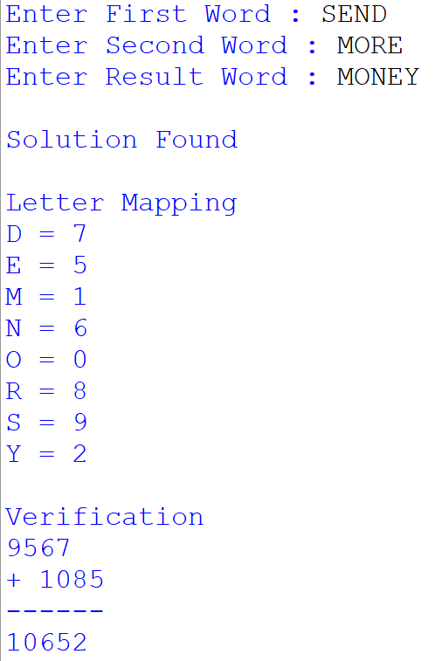
Output:
Result:

Thus, the Python program to solve the Crypt Arithmetic Problem was successfully executed, and the correct digit assignment satisfying the arithmetic expression was obtained.

